**Project 1**

<Mao Card Game>

**Section**

**CSC-17A 29837**

**Name**

**England, Cody**

**Date:**

**10/25/20**

Introduction:

Title: Game of Mao

This is a unique card game where players must figure out the rules as they play.

The base game play is like that of Uno, Crazy 8’s, where players work to get rid of all their cards first. The unique rules to this game, however, consist of actions that must be taken by the player after they play a card, if the card they played meets certain criteria.

(e.g. if a player places an Ace on top of a face card, then they have to clap their hands, or say something, etc.).

This is a constantly evolving game that changes depending on who you play it with, making it an incredibly fun mental challenge for those who enjoy such things.

Summary:

Project size: ~ 600 lines.

# Constants: 2

# Variables: ~ 28 non for loop variables

# Functions: 20

# .h files: 2

#Binary Files: 1[1]

Game Play and Rules:

Ground Rules:

* Each player is dealt 12 cards.
* A card can only be played if it has the same suit or face value as the top card of the discard pile.
* Play starts with Player 1 and then alternates between them and the AI player.
* First player to discard all their cards wins.

Mao Rules:

* Player must enter ‘1’ if an Ace is played.
* Player must enter ‘2’ if they play a card that changes the suit of the top discarded card (i.e. same face value is played but different suit).
* Player must enter ‘3’ if a run of two cards is played (e.g. A 6 of hearts followed by a 7 of hearts)

When they start the program, the player will by greeted with an introduction about the game of Mao and prompted to hit any key to begin the game. Upon doing so, a deck will be displayed face down, and on its right will be a card face up that constitutes the start of the discard pile.

Below the deck and discard pile, the player will see their randomly generated hand of 12 cards. At this point, an AI opponent has also been created.

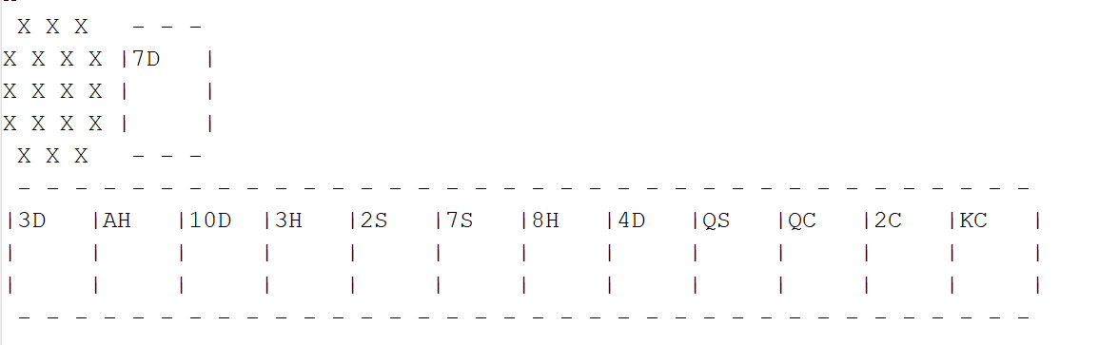

Figure 1: Start of Game

The player will be prompted to enter the face value and suit of the card they want play.

Mistypes are not penalized, and so a loop of the prompt will occur if the player enters a card not in their hand.

If a card is played that meets one of the Mao rule parameters, then a prompt will be displayed asking the player to enter 1, 2, or 3 as shown in figure 2.

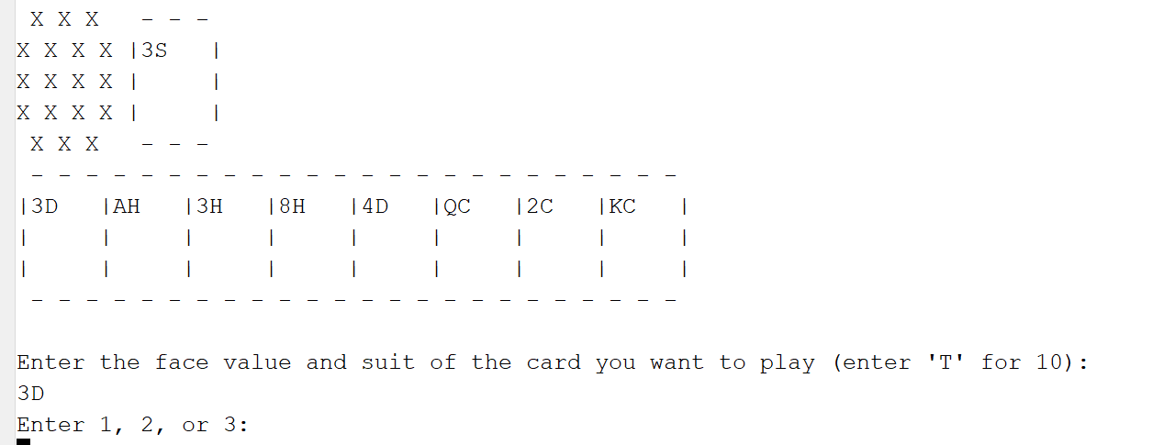

Figure 2 Menu Option

Here the player played a 3 of diamonds on a 3 of spades, thus changing the suit and generating the prompt.

Turns:

After Player 1 goes, then the AI opponent plays a card. Play continues until either Player 1 or AI is out of cards.

Penalties:

Penalties occur when either a card is played that does not match the suit or face value of the displayed card on the discard pile, or when Player 1 fails to enter the proper number to satisfy the Mao rule.

*Note: The AI is only programmed to have penalties occur for wrong suit or face value played, so be careful!

A penalty results in 1 card being added to your hand.

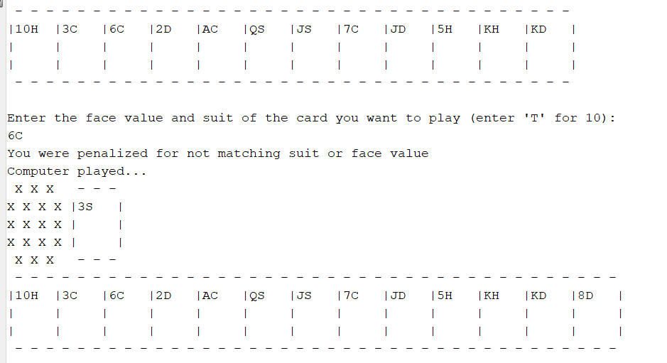

Figure 3 Penalty

As seen above, Player 1 played an invalid card. When their hand was redisplayed after the AI played a card, it has a new card added to it.

Winning:

Winning occurs when either player has played all their card. At this point the winner is declared and the game ends.

Technical:

Check off sheet:

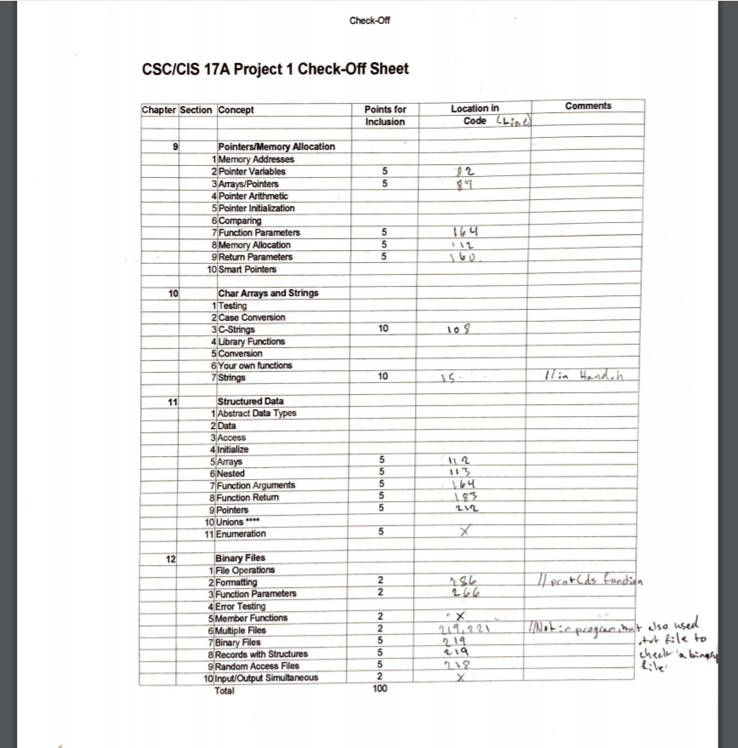

Some of the Major Variables:



Game Function Flowchart:

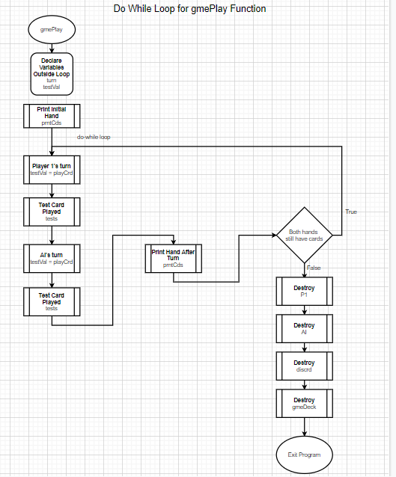

Future Versions:

This project consisted of 15.1 different versions that all built up to the final product. In testing, there is still some room for improvement. Given more time, I would allow the user to replay the game without having to rerun the program and, if they won, choose from a menu of Mao rules to add to the game. The AI player could also be expanded in sophistication and the one bug with the binary file to hole the AI hand could be resolved.

1. *There should be 2 files. Both the AI and Player 1 hands are written to and read from their respective files throughout the program, however I discovered in the final version of the program that the AI binary file was not appeared in my project folder.